|  |  |
| --- | --- |
| **Event Details** | |
| **Title of the Event:** | Caring for Her: A Gynaecologist's Perspective |
| **Date of the Event:** | 20 November 2024 |
| **Venue** | Einstein Hall |
| **SDG no** | 3,4,5 |
| **No. of Student Enrolled:** | 75 |
| **No. of Student Attended** | 75 |

Objective:

This semester’s final event was a heartfelt initiative aimed at creating a safe, supportive, and empowering space exclusively for girls to focus on their health and well-being. With an emphasis on fostering awareness and proactive self-care, the event brought together students and a renowned medical professional to address critical aspects of women’s health in an interactive and inclusive environment.

The highlight of the session was the presence of a renowned gynaecologist Dr. Pooja Mehta from Fortis Hospital, whose expertise and compassionate approach made the event both insightful and engaging. The session began with an in-depth discussion on key women’s health issues, covering topics like menstrual health, hormonal balance, stress management, and general lifestyle practices for maintaining long-term well-being. The gynaecologist addressed common health concerns faced by young women and emphasized the importance of preventive care, regular health checkups, and building a sustainable and healthy lifestyle.

To ensure the session was not just theoretical, health checkups were conducted as a crucial part of the event. Each participant had the opportunity to consult with the gynaecologist personally, allowing for tailored advice and care. These checkups helped identify individual health needs, ensuring that attendees left with actionable insights and a deeper understanding of their well-being.

The event was carefully structured to provide a welcoming and judgment-free environment. Participants were encouraged to share their thoughts, ask questions, and seek clarification on issues that they might have hesitated to discuss otherwise. This open dialogue fostered a sense of trust and camaraderie, making the session not only educational but also emotionally uplifting.

Beyond the medical aspects, the event reinforced the importance of community and mutual support. It highlighted the shared responsibility of creating an environment where women feel empowered to take charge of their health and well-being. The active participation of attendees and their enthusiasm to learn and engage were a testament to the session's success in addressing vital health issues.

As the final event of the semester, this initiative was a meaningful culmination of efforts to promote health awareness and self-care. It left a lasting impact by inspiring girls to prioritize their physical and mental health and equipping them with the knowledge and confidence to make informed decisions about their well-being. This event has set a strong precedent for future programs aimed at enhancing health awareness and fostering a culture of inclusivity and empowerment among young women.

**Outcomes:**

● **Health Awareness:** The event successfully enhanced participants' understanding of critical women’s health concerns, including menstrual health, hormonal balance, and lifestyle practices, creating a knowledge-rich environment focused on preventive care and well-being.

● **Empowerment through Knowledge:** Through the expert guidance of the gynecologist, participants were equipped with actionable insights to manage their health effectively, fostering confidence and encouraging proactive self-care.

● **Proactive Health Management:** The inclusion of personalized health checkups ensured that attendees received individual attention and tailored advice, motivating them to prioritize regular health assessments and adopt healthier lifestyle habits.

● **Supportive Community Building:** By creating a safe and judgment-free environment, the event nurtured a sense of community, encouraging participants to openly share their concerns and experiences, thereby promoting openness and mutual understanding.

● **Breaking Health Taboos:** The event provided a platform to discuss sensitive health topics, breaking societal taboos and normalizing conversations around women’s well-being, contributing to a more open and informed perspective on health issues.

● **Holistic Well-Being Focus:** Beyond addressing physical health, the session emphasized a balanced approach to mental and emotional well-being, encouraging participants to view health as a comprehensive and proactive state of living.

**Snapshots:**

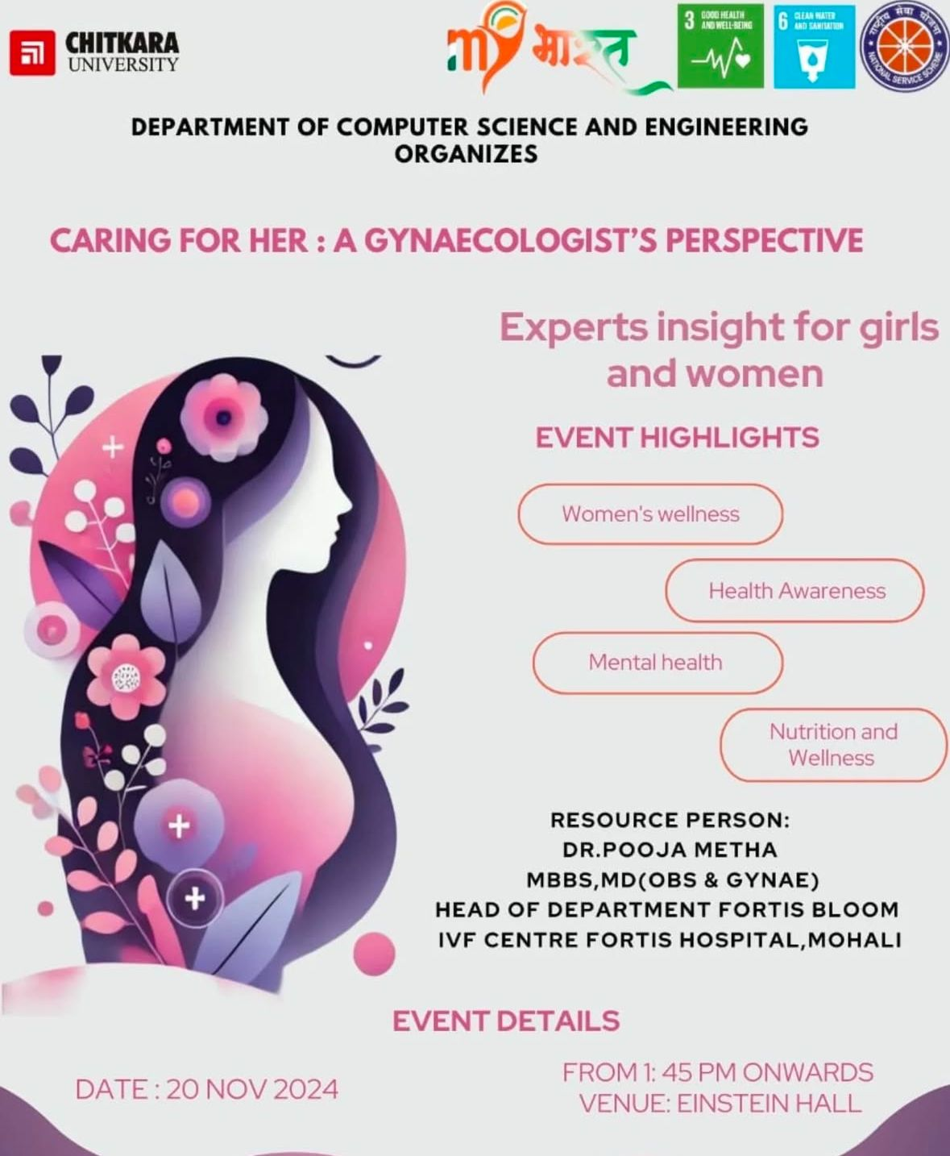

Caring for Her: A Gynaecologist's Perspective was an important and empowering event that highlighted the significance of women’s health from a professional viewpoint. Gynaecologists played a crucial role in addressing the unique health concerns that women faced throughout different stages of life. From menstrual health and reproductive issues to preventive care and lifestyle guidance, they offered expertise that supported physical, mental, and emotional well-being. Regular checkups and consultations with a gynaecologist were vital for early detection of health conditions, ensuring that women could lead healthier, happier lives. The session provided valuable knowledge, fostering an environment where women felt informed, confident, and cared for in their healthcare journey.

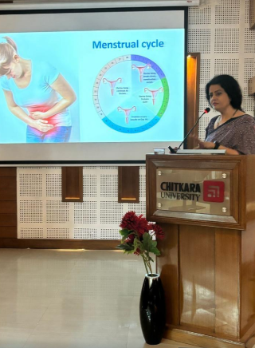

Dr. Pooja Mehta addressing the health issues faced by women these days and here she primarily focused on hormonal imbalances that can affect the menstrual cycle, such as thyroid disorders, polycystic ovary syndrome (PCOS), or pituitary gland issues.

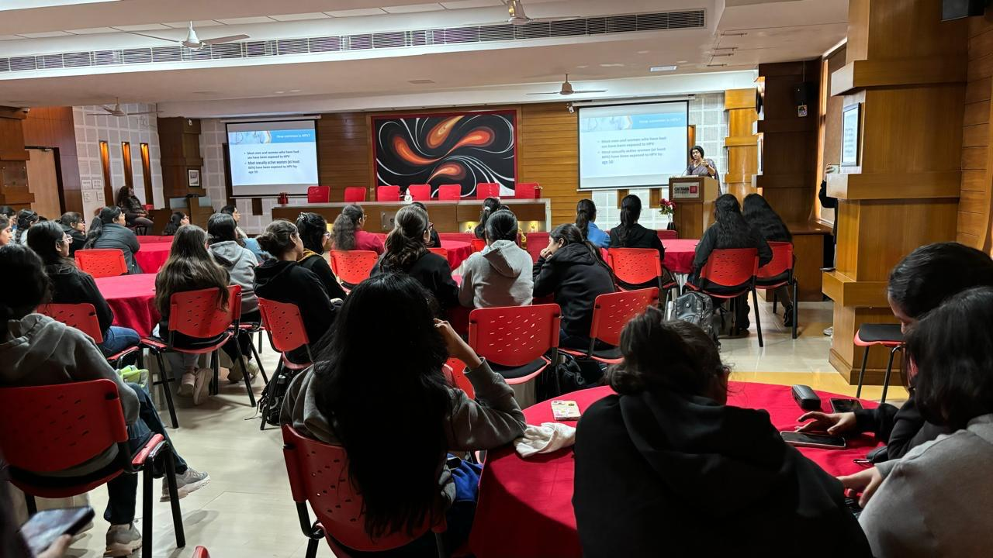

.

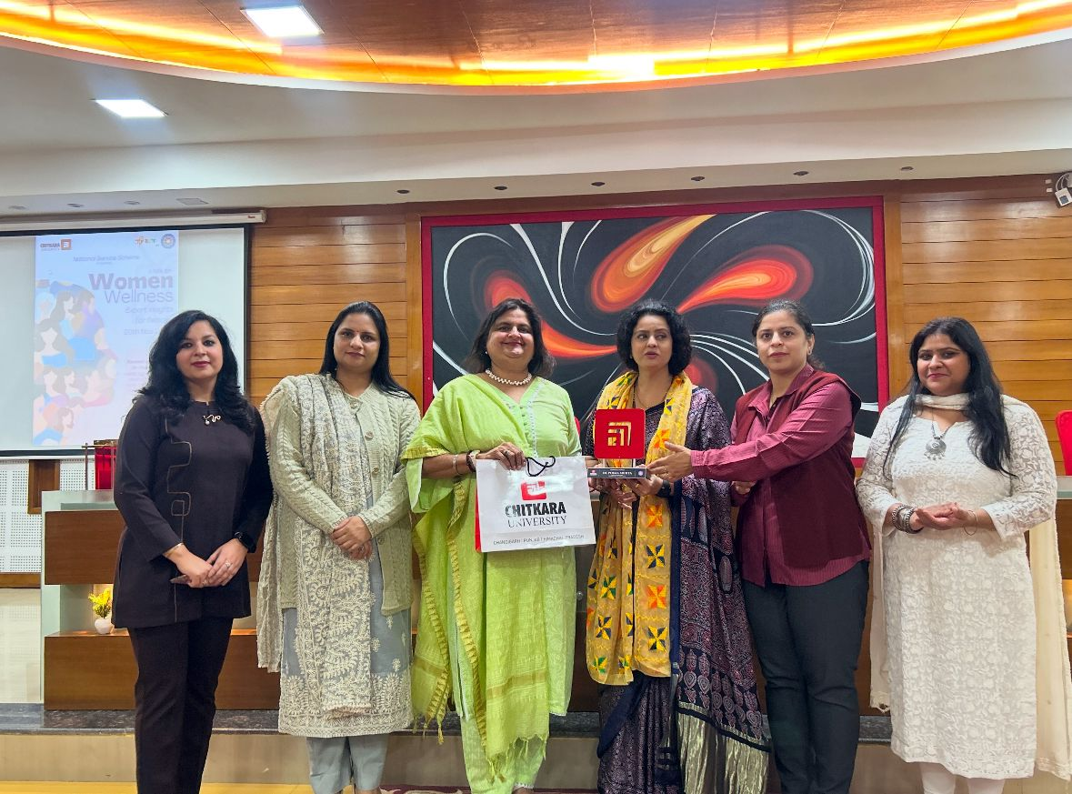

**Name and signature of the coordinator**